2018-2019 Application for Enrollment | 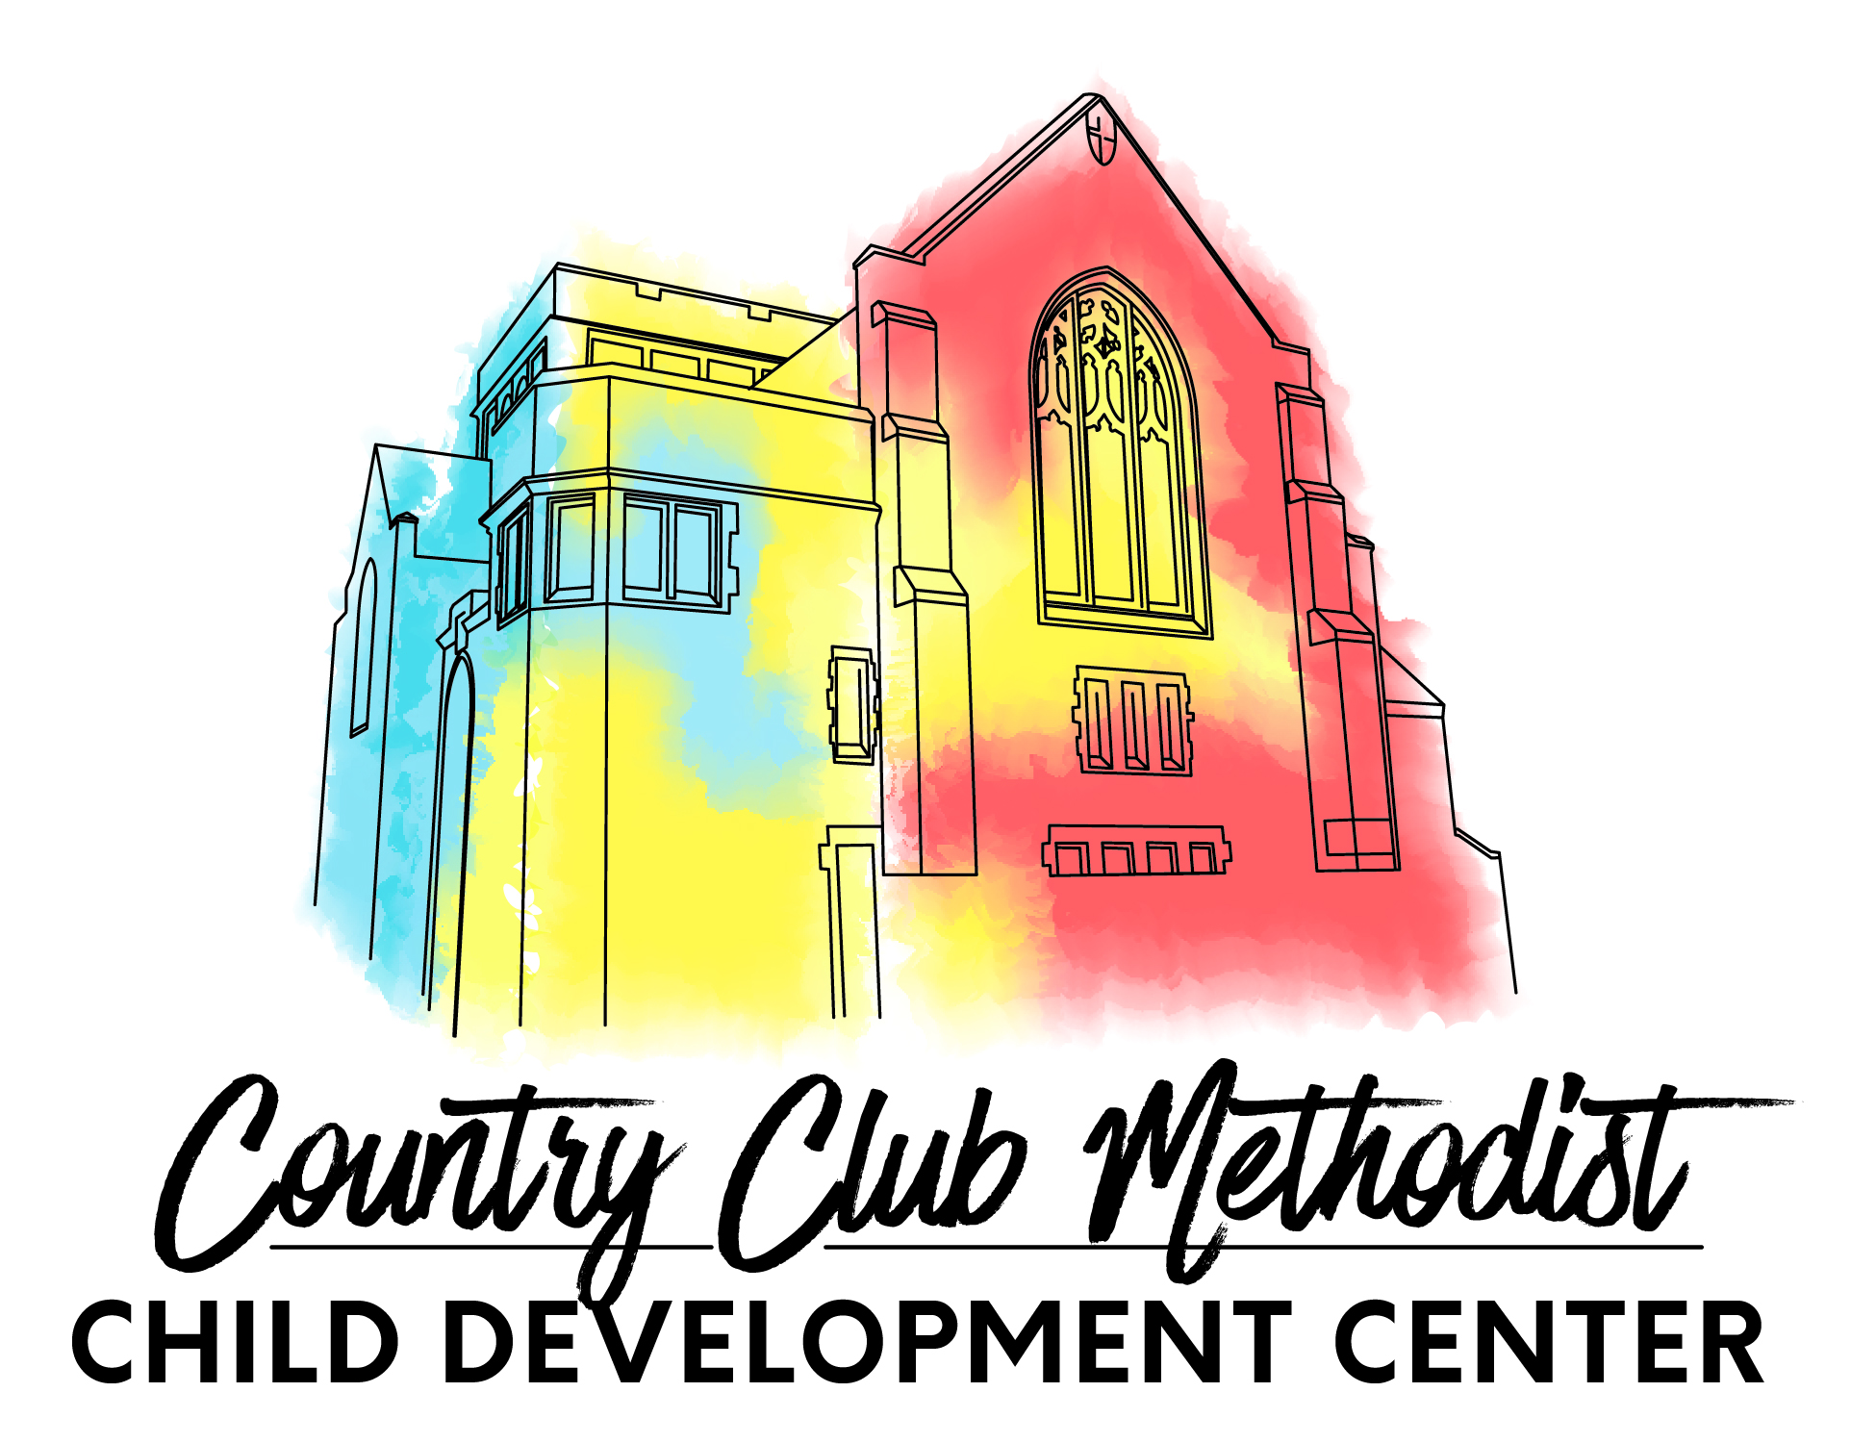
Country Club Methodist Child Development Center
400 West 57th Street, Kansas City, MO 64113
Phone 816.214.8824 countryclubmethodistcdc@gmail.com
www.countryclubmethodistcdc.com

Child’s full name | Date of Birth  (or expected DOB) | Desired Start Date | Sex | Age

Child lives with __ Mother __ Father __ Both ___ Other/Please specify ________________________________________
Names and ages of siblings in the home:
________________________________________________________________________________________________
Typical hours your child will attend: Drop off _______________________a.m. Pick up ______________________p.m.
(At this time we only offer full-time, Monday through Friday, care. However, if there are any days of the week your child would not regularly attend please list them below.)
________________________________________________________________________________________________
Is your child fully potty trained? _____ yes _____no Is your child walking? _____ yes _____no

Parent/Guardian _________________________________________________ Home Phone ______________________
Cell phone(s)____________________________________________________ Work Phone ______________________
Address ____________________________ City ________________________ State _______ Zip _________________
Email ______________________________ Employer ___________________ Hours ___________________________
Work Address _______________________ City ________________________ State _______ Zip _________________

Parent/Guardian _________________________________________________ Home Phone ______________________
Cell phone(s)____________________________________________________ Work Phone ______________________
Address ____________________________ City ________________________ State _______ Zip _________________
Email ______________________________ Employer ____________________ Hours ___________________________
Work Address _______________________ City ________________________ State _______ Zip _________________
Tuition | Monthly | Deposit (Non-refundable)
Infant (6 weeks – 16 months), | $1150 | $575
Toddler (16 months – 36 months) | $1150 | $575
Early Preschool (2-1/2 – 3-1/2 yrs) | $925 | $462.50
Preschool 2 (3-5 years) | $925 | $462.50

If enrolling more than one child please fill out a separate application for each child. If your child(ren) is selected for enrollment, a $100 non- refundable enrollment fee (for each child) along with the deposit (listed above) is due immediately to hold a place.The initial deposit is put towards your first month's tuition. Please make checks payable to Country Club Methodist CDC.

Parent/Guardian Signature _________________________________________________ Date ___________________

