2019 Enrollment for Summer Camp | 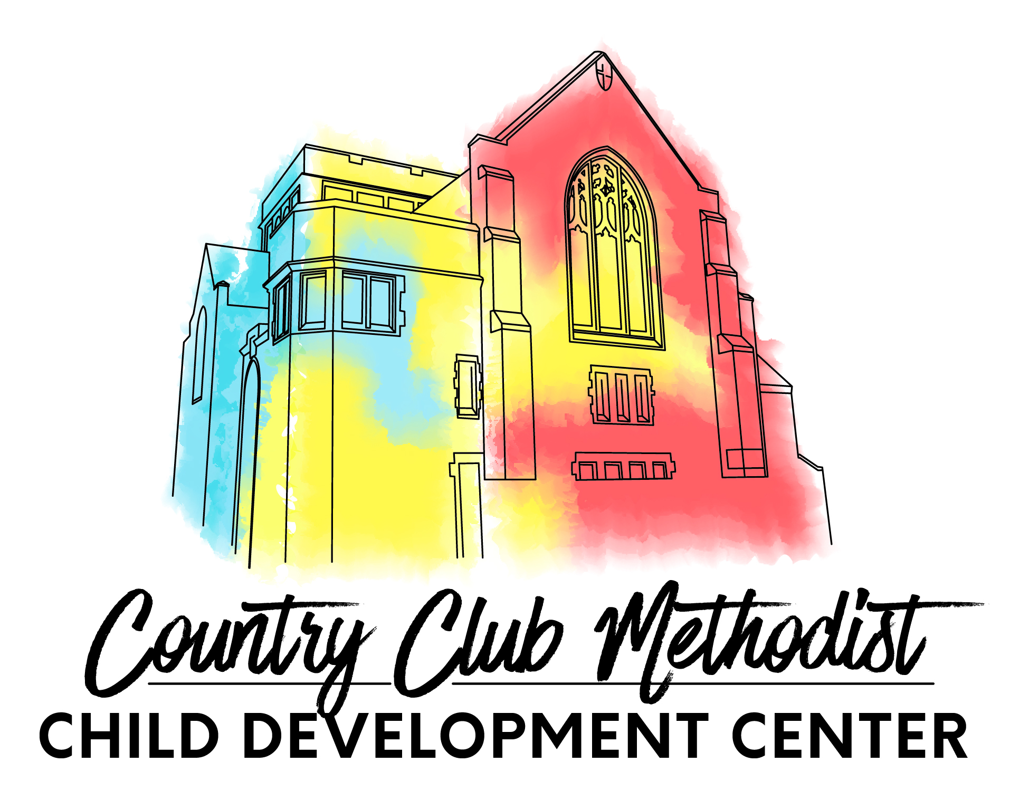
Country Club Methodist Child Development Center
400 West 57th Street, Kansas City, MO 64113
Phone 816.214.8824 countryclubmethodistcdc@gmail.com
www.countryclubmethodistcdc.com facebook.com/ccmcdc

Child’s Full Name | Date of Birth | Age | Sex | Fully potty-trained?  *required for summer camp | Does your child nap? If so, list typical duration.

Parent/Guardian _________________________________________________ Home Phone ______________________
Cell phone(s)____________________________________________________ Work Phone ______________________
Address ____________________________ City ________________________ State _______ Zip _________________
Email ______________________________ Employer ___________________ Hours ___________________________
Work Address _______________________ City ________________________ State _______ Zip _________________

Parent/Guardian _________________________________________________ Home Phone ______________________
Cell phone(s)____________________________________________________ Work Phone ______________________
Address ____________________________ City ________________________ State _______ Zip _________________
Email ______________________________ Employer ____________________ Hours ___________________________
Work Address _______________________ City ________________________ State _______ Zip _________________

Summer Camp Dates: May 28-August 16
Please mark the desired weeks of attendance below. Priority will be given to families enrolling in 8+ weeks of consecutive summer care. If enrolling for 8+ weeks, please check desired weeks of care. If enrolling for less than 8 weeks, please choose one or more of the following sessions: session 1, session 2, session 3, or session 4. Minimum of 1 session (3 weeks) required for summer camp enrollees. Tuition is $250/week, regardless of sick days, holidays, or inservice days. This fee includes all activities and materials, as well as breakfast lunch, and an afternoon snack.
5/28 | 6/3 | 6/10 | 6/17 | 6/24 | 7/1 | 7/8 | 7/15 | 7/22 | 7/29 | 8/5 | 8/12
*Please contact the center if you are in need of summer care outside of the dates offered, as additional availability may be possible.
**Summer camp availability is on a first come, first served basis, as we have limited summer spots available. Priority is given to children attending 8+ weeks. Part-time (MWF or TTH) may be available dependent on demand.
***CCMCDC will be closed the following dates for holidays and professional development: 5/27, 6/14, 7/4, 8/16
Are the dates you selected flexible? ________
If interested in part-time care, please select one of the following: ____ MWF or ____ TTH

Deposit
At the time of enrollment, we require payment of our summer enrollment fee $50 as well as a deposit totaling $250, which will be applied to your child’s first week in care. Both the enrollment fee and deposit are non-refundable. Checks should be made out to CCMCDC and can be mailed to 400 W 57th Street Kansas City, MO 64113 or can be dropped off in our mail slot located at the 57th Street entrance under the red awning. Applications can be submitted via email or physically with check.

Parent/Guardian Signature _________________________________________________ Date ___________________

