2019 Application for Enrollment | 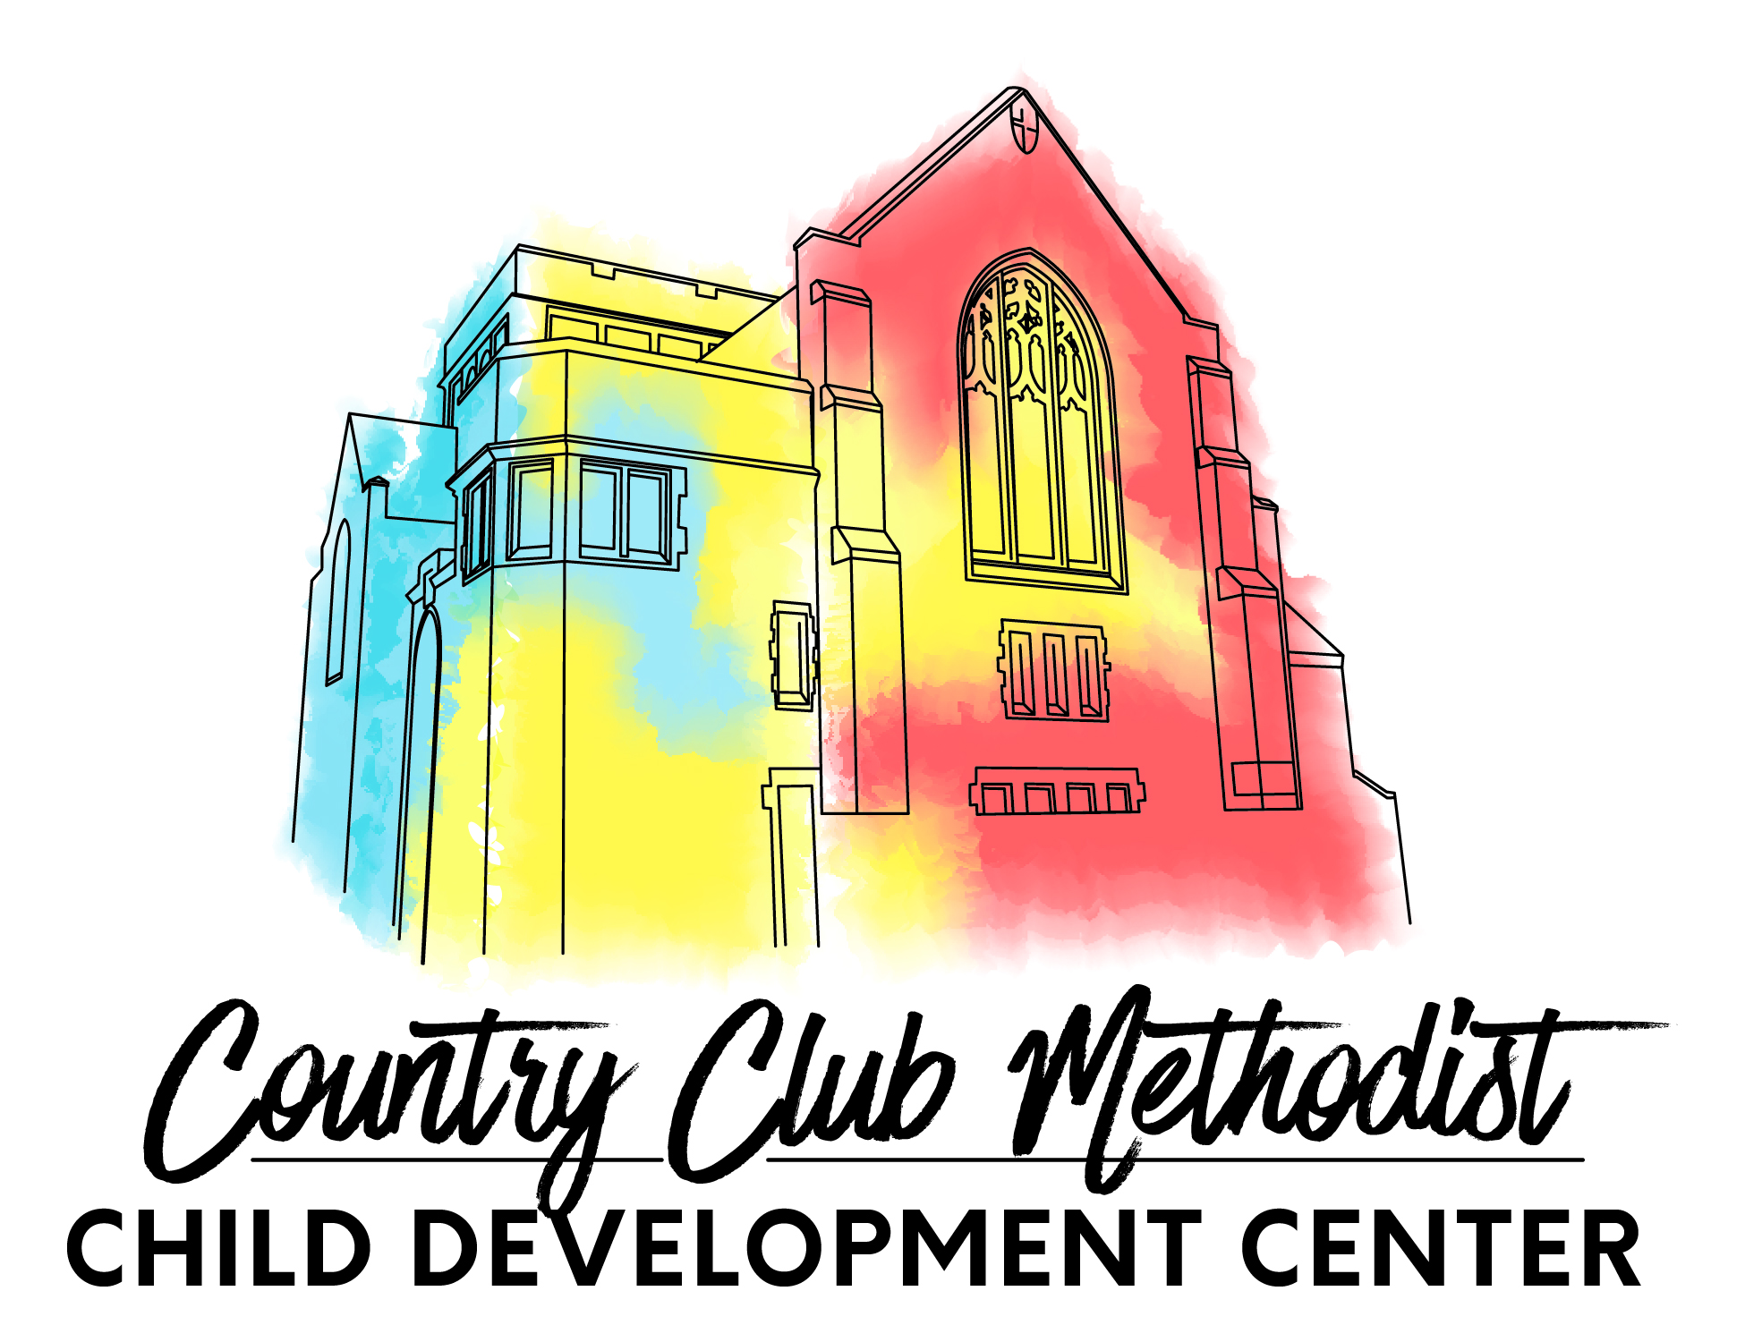
Country Club Methodist Child Development Center
400 West 57th Street, Kansas City, MO 64113
Phone 816.214.8824 countryclubmethodistcdc@gmail.com
www.countryclubmethodistcdc.com

Child’s full name | Date of Birth  (or expected DOB) | Desired Start Date | Sex | Age

Child lives with __ Mother __ Father __ Both ___ Other/Please specify ________________________________________
Names and ages of siblings in the home:
________________________________________________________________________________________________
Typical hours your child will attend: Drop off _______________________a.m. Pick up ______________________p.m.
(At this time we only offer full-time, Monday through Friday, care. However, if there are any days of the week your child would not regularly attend please list them below.)
________________________________________________________________________________________________
Is your child fully potty-trained? _____ yes _____no Is your child walking? _____ yes _____no

Parent/Guardian _________________________________________________ Home Phone ______________________
Cell phone(s)____________________________________________________ Work Phone ______________________
Address ____________________________ City ________________________ State _______ Zip _________________
Email ______________________________ Employer ___________________ Hours ___________________________
Work Address _______________________ City ________________________ State _______ Zip _________________

Parent/Guardian _________________________________________________ Home Phone ______________________
Cell phone(s)____________________________________________________ Work Phone ______________________
Address ____________________________ City ________________________ State _______ Zip _________________
Email ______________________________ Employer ____________________ Hours ___________________________
Work Address _______________________ City ________________________ State _______ Zip _________________
Tuition | Monthly (Full-time) | Monthly MWF  (Part-time) | Monthly TTH  (Part-time) | Deposit (Non-refundable)
Infant (6 weeks – 16 months), | $1150 | NA | NA | $575
Toddler (16 months – 36 months) | $1150 | NA | NA | $575
Early Preschool (2 year olds) | $1050 | NA | NA | $525
Preschool (2 year olds) | $1050 | $715 | $495 | $525 FT, $357.50 MWF, $247.50 TTH
Preschool (3-5 year olds) | $925 | $637 | $441 | $462.50 FT, $318.50 MWF, $220.50 TTH

If enrolling more than one child please fill out a separate application for each child. If your child(ren) is selected for enrollment, a $100 non-refundable enrollment fee (for each child) along with the deposit (listed above) is due immediately to hold a place. The initial deposit is put towards your first month's tuition. An application fee of $30/child is collected when submitting this form. Once this application and fee are submitted your child will be added to our wait list. Please make checks payable to Country Club Methodist CDC.

Parent/Guardian Signature _________________________________________________ Date ___________________

